**The Butterfly Club Registration Form**

Child’s Name: __________________________________________________________

Age: _______ Date of Birth: ______________________________________________

Address: ______________________________________________________________

T-Shirt Size: S M L XL (circle one)

Parent/ Guardian’s Name: ________________________________________________

Home: _______________ Cell: __________________Work: _____________________

Email: ________________________________________________________________

Allergies: ______________________________________________________________

______________________________________________________________________

Emergency Contact Info

Name: ________________________________________________________________

Telephone Contact: (hm)____________(cell)___________ (other) _________________

*The club uniforms consist of the club T-Shirt, and a black bottom (Skort shorts, or skirt).*

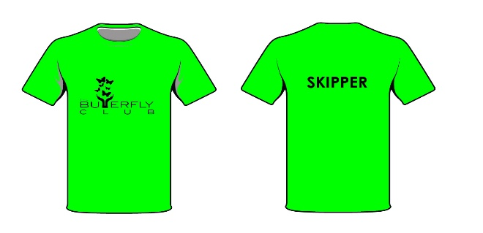

Ages: 7-9 SKIPPER

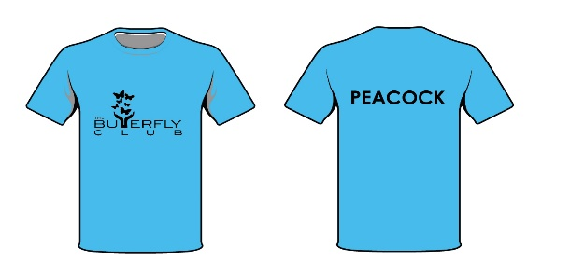

Ages: 10-13 PEACOCK

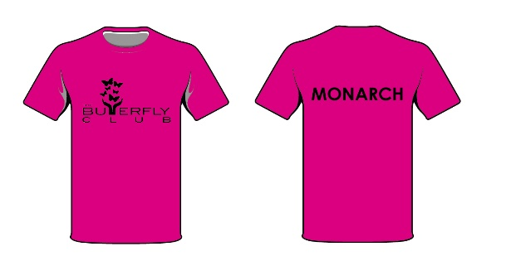

Ages: 14- 18 MONARCH